**AML Assignment – 2**

**Goli Sai Priyanka**

Analysing the Relationship Between Training Sample Size and Neural Network Selection for Image Categorization.

This document covers the building of a convolutional neural network (CNN), a sort of specialized software. The purpose of this software is to determine whether an image contains a dog or a cat. The images used to train the algorithms originate from Kaggle. Despite the fact that there are thousands of photographs available, the software is trained on only a subset of the 2000 images.

**Q1: Consider the Cats & Dogs example. Start initially with a training sample of 1000, a validation sample of 500, and a test sample of 500 (like in the text). Use any technique to reduce overfitting and improve performance in developing a network you train from scratch. What performance did you achieve?**

A. The computer model trained on a dataset of 1000 images after it had been trained on a sample of 500 more images. Later, 500 additional pictures were used to fully confirm the model's efficacy. To prevent overfitting, the program's reliance on the training dataset was limited by the use of a novel method known as dropout. The preprocessing steps included ensuring color accuracy, resizing the photographs, and converting the picture files into a computer-readable format. During training, the software's accuracy rate was approximately 71.30 percent; however, during testing, it demonstrated an accuracy rate of approximately 99.70 percent.

**Q2: Increase your training sample size. You may pick any amount. Keep the validation and test samples the same as above. Optimize your network (again training from scratch). What performance did you achieve?**

A. A larger dataset with 1500 photographs was used to train the computer model. And a subset of 500 photographs was used for validation during the training phase, while an additional 500 images were employed for testing. Utilizing augmentation techniques like visual flipping, rotation, and zooming significantly enhanced the program's learning capabilities. The program therefore functioned better when these tactics were applied. It achieved 86.05% accuracy during the training phase and demonstrated 80.30% accuracy throughout the validation phase as well.

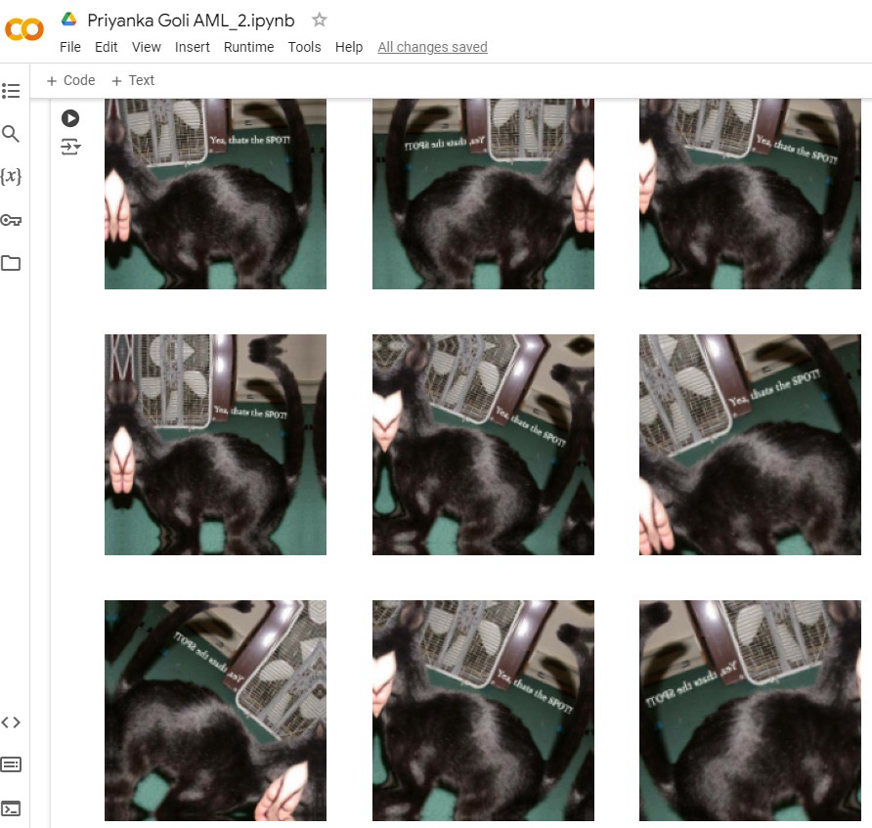

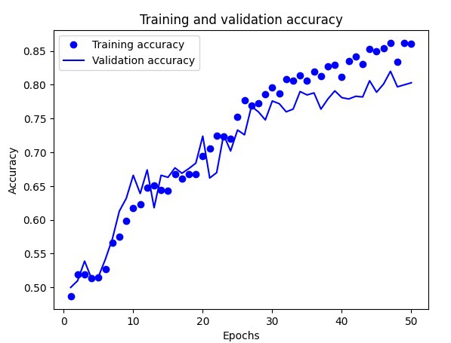

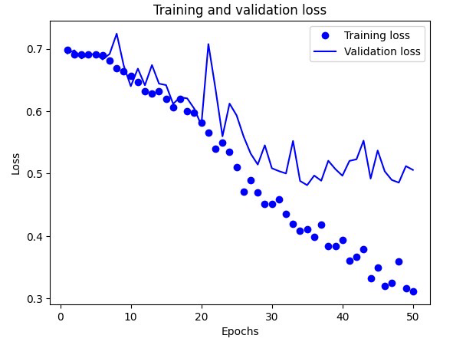

**Q3: Now change your training sample so that you achieve better performance than those from Steps 1 and 2. This sample size may be larger, or smaller than the previous steps. The objective is to find the ideal training sample size to get the best prediction results.**

A. To increase the computational model's effectiveness, a bigger dataset of 2000 images were used. These images were frequently enhanced using methods including flipping, rotating, & zooming during the training phase. The use of augmentation techniques with this larger dataset greatly improved the program's comprehension of images. As a result, the program's accuracy rate was approximately 78.60% during the validation phase and 85.85% during the training phase.

**Q4: Repeat Steps 1-3, but now using a pre-trained network. The sample sizes you use in Steps 2 and 3 for the pre-trained network may be the same or different from those using the network where you trained from scratch. Again, use any and all optimization techniques to get the best performance**.

A. **Prior Training Without Augmentation:**  
We carried out our investigation using a pre-trained model, which refers to the usage of a model that has already been trained on a significant number of photographs, without the use of augmentation procedures. Nevertheless, in this instance, we didn't apply any augmentation techniques to the images, such rotation or flipping. Despite the absence of these techniques, the pre-trained model showed remarkable photo identification performance. It had a remarkable accuracy rate of 99.99% which is nearly 100% throughout the training phase, which is encouraging. However, this high accuracy could also indicate that the model is too dependent on the training dataset and is not flexible enough to handle new inputs. During validation, the model's accuracy was approximately 97.60%, indicating potential challenges in extending its performance beyond the training dataset.

**Pre-Trained with Augmentation:**

The pre-trained model showed outstanding performance with no need for additional adjustments to supplement the dataset, attaining a validation accuracy of 97.50%. The author then experimented with a fine-tuning technique, which entails modifying the pre-trained model slightly to increase its suitability for the specific task at hand. The model functioned more competently once data augmentation techniques have been used and further adjustments were made. Approximately 99.15% accuracy was shown during training, while 97.50% accuracy was shown during validation.

**Fine-Tuning with Augmentation:**

To further enhance the model's performance, I experimented with the pre-trained model and changed how extra data augmentation was applied. This process is known as fine-tuning. Fine-tuning comprises making modifications to the pre-trained model to maximize its fit for the particular task at hand. The layers of the previously trained model were able to adapt to the newly richer information as a result of techniques for augmentation like flipping and rotation. Along the fine-tuning phase, significant progress was made, increasing the accuracy of the model throughout the entire instruction. The model has shown 99.80% accuracy was shown during training, while 97.50% accuracy was shown during validation.

**Conclusion:**

In conclusion, the quality and quantity of data that the model consumes determines how effective it is. When the training dataset was increased from 1000 to 2000 pictures, test results revealed enhanced recognition performance, with accuracy rising from 80% to 97.7%. Combining techniques for growing the dataset with a pre-trained model yields even better outcomes. In summary, the author argues that expanding the dataset and applying data augmentation techniques can improve the model's understanding of the subject and enable it to produce predictions that are more accurate.